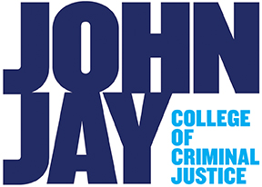
Global Economic Development and Crime
Instructor: Hakan Yilmaz
Contact: hyilmaz@jjay.cuny.edu
Time: TTH 3.05 -4.20
Room: New Building 1.90
Office Hours: TH 2.05-3.05 (email me if you would like to come)
Required Text: The Process of Economic
Development by Cyber and Dietz (3rd or 4th edition)

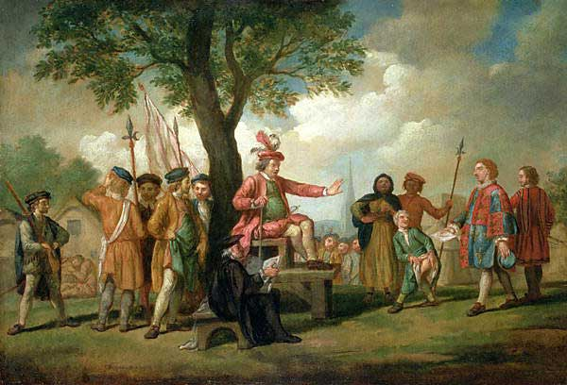

This is a course in economic development and crime. We will explore theories of economic development before, and within different stages of capitalism. We will also explore the dynamics of global development and how capitalism leads to uneven and combined development across different geographies. Finally, we will explore the relationship between crime, incarceration, and economic development in the US.

By the end of this course students should understand different theories of economic development, history of global economic development throughout the capitalist period and the relationship between economic development, crime, and incarceration.

Evaluation and Assessment

The grading scale will be the following (grades rounded to the nearest whole number):

A: 100-93 % | A-: 92-90 %
B+: 89-87 % | B: 86-83 % | B-: 82-80 %
C+: 79-77 % | C: 76-73 % | C-: 72-70 %
D+: 69-67 % | D: 66-63 % | D-: 63-60 %
F: Less than 60 %

You will be graded on the following components of the course:

*Attendance and participation 10%
*Assignments 30%
*Midterm Exam 30%
*Take Home Final 30%

Following is the weekly schedule for the semester.

Week and Dates | Topics | Readings
Week 1 | Syllabus day, Crime and Development
Week 2 | Development before Capitalism: Malthus | Chapter 4, Agrarian Class Structure and Economic Development in Pre-Industrial Europe by Robert Brenner
Week 3 | Smith | Chapter 4
Week 4 | The So-Called Primitive Accumulation and Colonization | Chapter 3
Week 5 | Classical and Neoclassical Theories | Chapter 4
Week 6 | Developmentalism | Chapter 5
Week 7 | Heterodox Theories | Chapter 6
Week 8 | Neoclassical Theories of Development | Chapter 7
Week 9 | Post-War Boom and Neoliberalism | Chapter 9 and The First Great Depression of the 21st Century by Anwar Shaikh
Week 10 | International Politics of Development | Chapters 2-4 from Debt, the IMF, and the World Bank: Sixty Questions, Sixty Answers  By Eric Toussaint, Damien Millet
Week 11 | Global Development | Chapters 2-4 from Debt, the IMF, and the World Bank: Sixty Questions, Sixty Answers  By Eric Toussaint, Damien Millet
Week 12 | Midterm Exam
Week 13 | Development and Underdevelopment within the US
Week 14 | Economic Origins of Mass Incarceration
Week 15 | Racial Economics of Mass Incarceration
Finals Week

Late Policy
Assignments can be submitted within two days of the assigned deadline with 10% penalty for each day. There will be no late submissions for the Take Home Final – although exceptions will be made under special circumstances.

Extra Credit
Extra Credit can be assigned on requests by students. You can increase your grade by up to 5% through completing an extra credit assignment. The form and content of the assignment will depend on students’ interests.

Suggestions for Success
Your assignments and paper will be graded according to the introductory nature of the course. Students that participate in class discussion and turn in their assignments on time and according to the given guidelines will be rewarded with good grades.

John Jay Policies

Disability Policy
Students with disabilities who request classroom or exam accommodations should let me know ASAP For your information, the phone number for Student Accessibility Services is (212) 237-8031.

Academic Honesty
John Jay’s Academic Honesty Policy is as follows:
http://www.jjay.cuny.edu/web_images/Policyand_Procedures.pdf
If you plagiarize on your assignments or exams, you will be penalized. I reserve the right to use plagiarism detection tools. Please cite all work in Chicago Manual of style. Use the following for citations:

http://www.easybib.com/guides/citation-guides/chicago-turabian/

Writing Center
If you’re having trouble with the course because of your writing skills, the writing center is a great way to improve your grade. The office is at 2450N.

Wellness Center
If you face challenges securing food, transport, housing and believe that this may affect your performance in your classes, or your ability to remain enrolled at John Jay, you are urged to contact the Wellness Center (212-237-8111 / L68 NB) for support.

